OpenVPN Installation Document

Step 1: Download the OpenVPN configuration files from the local machine.

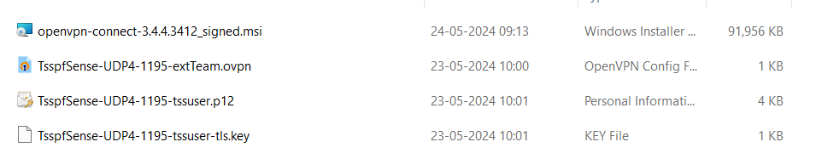

Step 2: Install the OpenVPN Tsspfsence file.



Step 3: Copy and paste the other three files to the following paths

C:\Users\Your UserName \OpenVPN\config\TsspfSense-UDP4-1195-extTeam

C:\Program Files\OpenVPN\config



Step 4: After moving the files, you should see the icon in the taskbar.

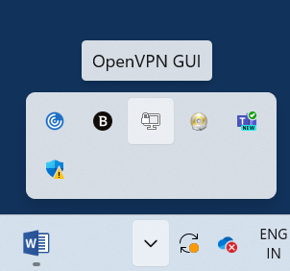

Step 5: Right-click the OpenVPN GUI icon, select the 'Import' option, and click on it.

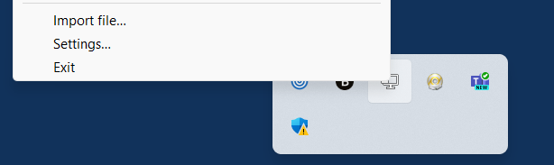

Step 6: It will display the path "C:\Program Files\OpenVPN\config". Select the OpenVPN config file and upload it.



Step 7: It will display a message confirming successful upload.

Step 8: Right-click on the OpenVPN GUI. It will display additional options, including "TSSPFSence-UDP4-1195-extTeam". Select "CONNECT

Step 8: A window will pop up prompting you to enter your username and password. Once you've entered your credentials, OpenVPN will connect.

Step 9: For confirmation, the OpenVPN interface should resemble this.

